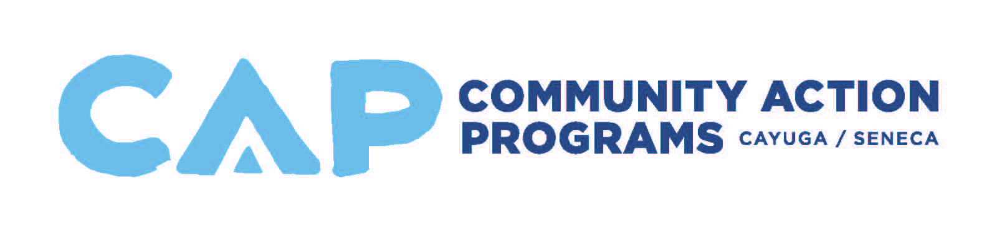
Marketing & Development Assistant
Job Description

Reports to: Marketing & Development Assistant
Employment Classification: Non-Exempt Updated: December 2019

JOB SUMMARY: The Marketing and Development Assistant provides administrative support to the Marketing and Development Director to increase public awareness of and participation in the Agency’s mission and programs, and to communicate the Agency’s value and contributions to potential donors and funders. The Assistant supports the Marketing and Development Director in the areas of marketing, public relations, planning, program development, and fundraising including grant writing, events planning and donor development.

Essential Job Functions:

- Effectively communicate the Agency’s mission, history, services and outcomes to the public, partners, and funders.
- Track, maintain and update donor, development, and marketing databases/records used for recording donations, returned direct-mail pieces, and developing marketing/event-related support including raffle/auction donations.
- Assist with all aspects of the planning and execution of fundraising events/campaigns, including the solicitation and securement of prizes and sponsorships.
- Process all donations and sponsorships, prepare acknowledgement and thank you letters, and other donor and event-related correspondence.
- Update and photocopy all agency-used collateral materials.
- Research prospective corporate, foundation, individual, and raffle donors.
- Identify and secure agency-wide news stories, photos, and details from program directors; develop content for monthly newsletter, press releases, calendar insertions, and social media posts.
- Represent and promote CAP at networking, community outreach, and agency fundraising events.
- Edit agency website related to staff changes, event details, weekly updates, etc.
- Compose, compile, edit, produce, and distribute a variety of documents, including proposals, press releases, testimonials, donor correspondence, thank you letters, reports, marketing materials, and presentations.
- Compose and post online content to Agency social media sites
- Support the submission of Agency funding requests including but not limited to collection of data from a variety of sources, development of narrative and budgets, gathering of necessary supporting documentation, and application assembly.
- Assist with various research and/or special projects including the Agency’s Community Needs Assessment, Strategic Plan and Poverty Simulations.
- Perform a broad range of general office support functions including creating and/or maintaining files and records, photocopying, faxing, maintaining current mailing lists, completing mail merges, etc.
- All other duties and responsibilities as requested by the Marketing & Development Director and/or Executive Director

Supervisory Responsibilities:
The Marketing and Development Assistant does not have supervisory responsibilities.

Qualification Standards:
The Marketing and Development Assistant must have the following minimum qualifications:
- An Associates’ degree in Marketing, Communications, Public Relations, English, Writing, or related field, with 1-2 years successful experience in a position that includes marketing, communications, development, proposal preparation, writing, events planning, and/or fundraising preferred; or any similar combination of education and experience.
- Outstanding writing and proofreading skills, including the ability to create original, creative, and persuasive correspondence and messaging.
- Must have attention to detail, be well organized, and be willing to work occasionally at events outside of regular business hours.
- Excellent written and oral communication, public presentation, and interpersonal skills required.
- Demonstrated experience with marketing and outreach initiatives including social media marketing, preferably within a non-profit environment.
- Demonstrated experience with fundraising and event planning.
- Excellent computer skills, proficiency in typing and the ability to utilize various software programs, such as but not limited to, Microsoft Office Suite, Adobe Software, Acrobat Pro.
- Experience with donor databases, graphic design software, WordPress and email marketing software preferred.
- Experience with grant writing and budgeting preferred.
- Ability to work independently, set priorities, and complete work accurately and in sufficient time for review.
- Must have strong organizational skills and demonstrated ability to handle a wide variety of projects and assignments simultaneously.
- Ability to operate under solid pressure and meet tight deadlines.
- Ability to relate to all socio-economical segments of the community and work well with both professional and non-professional individuals.
- Must have reliable transportation and a clean and valid NYS driver’s license.

Equipment, Machines and Software Used:
Ability to operate a computer, printer, telephone, photocopier, fax machine, digital camera, and calculator.

Physical and Mental Requirements:
- Ability to exert up to 20 pounds of force occasionally, and/or up to 10 pounds of force frequently, and/or a negligible amount of force constantly to move objects.
- Close mental and visual attention required to perform work dealing primarily with preparing and analyzing data and figures, performing accounting work, using a computer terminal, and/or extensive reading.
- While performing the duties of this position, the employee is regularly required to sit for extended periods of time, stand, walk, talk, hear, reach, use hands to finger, grasp, handle, or feel, and perform repetitive motions of hands and/or wrists.

Environmental Conditions:
There is no exposure to adverse environmental conditions. Work is performed in a typical office work environment with outside travel.

Employer’s Disclaimer:
- All requirements are subject to possible modification to reasonably accommodate individuals with disabilities.
- This job description in no way states or implies that these are the only duties to be performed by the employee occupying this position. Employees will be required to follow any other job-related instructions and to perform any other job-related duties requested by their supervisor. Furthermore, the company reserves the right to add to or revise an employee's job duties at any time at its sole discretion.
- This document does not create an employment contract, implied or otherwise, other than an “at will” employment relationship.

